**COL 215 – Mini Project**

Yash Malviya 2016CS50403

Hardik Khichi 2016CS50404

16 bit CRC Computation

1. Specifications:

A **Cyclic Redundancy Check** (**CRC**) is an [error-detecting code](https://en.wikipedia.org/wiki/Error_detection_and_correction) commonly used in digital [networks](https://en.wikipedia.org/wiki/Telecommunications_network) and storage devices to detect accidental changes to raw data. Blocks of data entering these systems get a short *check value* attached, based on the remainder of a [polynomial division](https://en.wikipedia.org/wiki/Polynomial_long_division) of their contents. On retrieval, the calculation is repeated and, in the event the check values do not match, corrective action can be taken against data corruption. CRCs can be used for error correction.

CRCs are so called because the *check* (data verification) value is a *redundancy* (it expands the message without adding [information](https://en.wikipedia.org/wiki/Entropy_(information_theory))) and the [algorithm](https://en.wikipedia.org/wiki/Algorithm) is based on [*cyclic* codes](https://en.wikipedia.org/wiki/Cyclic_code).

CRC-CCITT polynomial is chosen by sender and receiver.

16 bit CRC-CCITT is calculated by dividing 1111111111111111 (initial value) prefixed and 0000000000000000 (augmentation) suffixed to 16bit message by the CRC-CCITT polynomial

The remainder is CRC.

1. Overall approach:

We will make a finite state machine similar to divider circuit when load button is pressed 1111111111111111 (initial value) and 0000000000000000 (augmented value) prefixed and suffixed to 16bit message respectively. Then this value is divided by pre-decided CRC polynomial using division algorithm but because quotient is not used it is not even stored. When calculation is complete a done signal is turned on. When reset is pressed 0xFFFF is displayed

1. Block diagram:

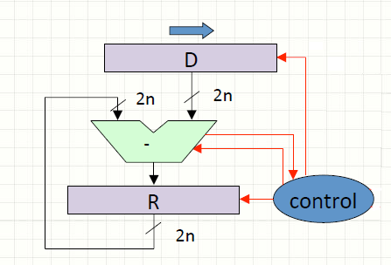

1. Test and demonstration plan:

We will run random test case manually on the board and check their corresponding CRC with online CRC calculator